READING | WRITING | MATH | SCIENCE | SOCIAL STUDIES
- Plot  - Story Structure  - Graphic organizers  -We will be reading  “Big Grunt and the Little Egg”  (copy given to student) | - Nouns  - Opinion Writing  - Writing Process | - Continue Money  - Multiplication  - Set #3 Test 2 Thursday | - Space/  planets | - Weekly Reader newspaper #3  - Maps  - Landforms
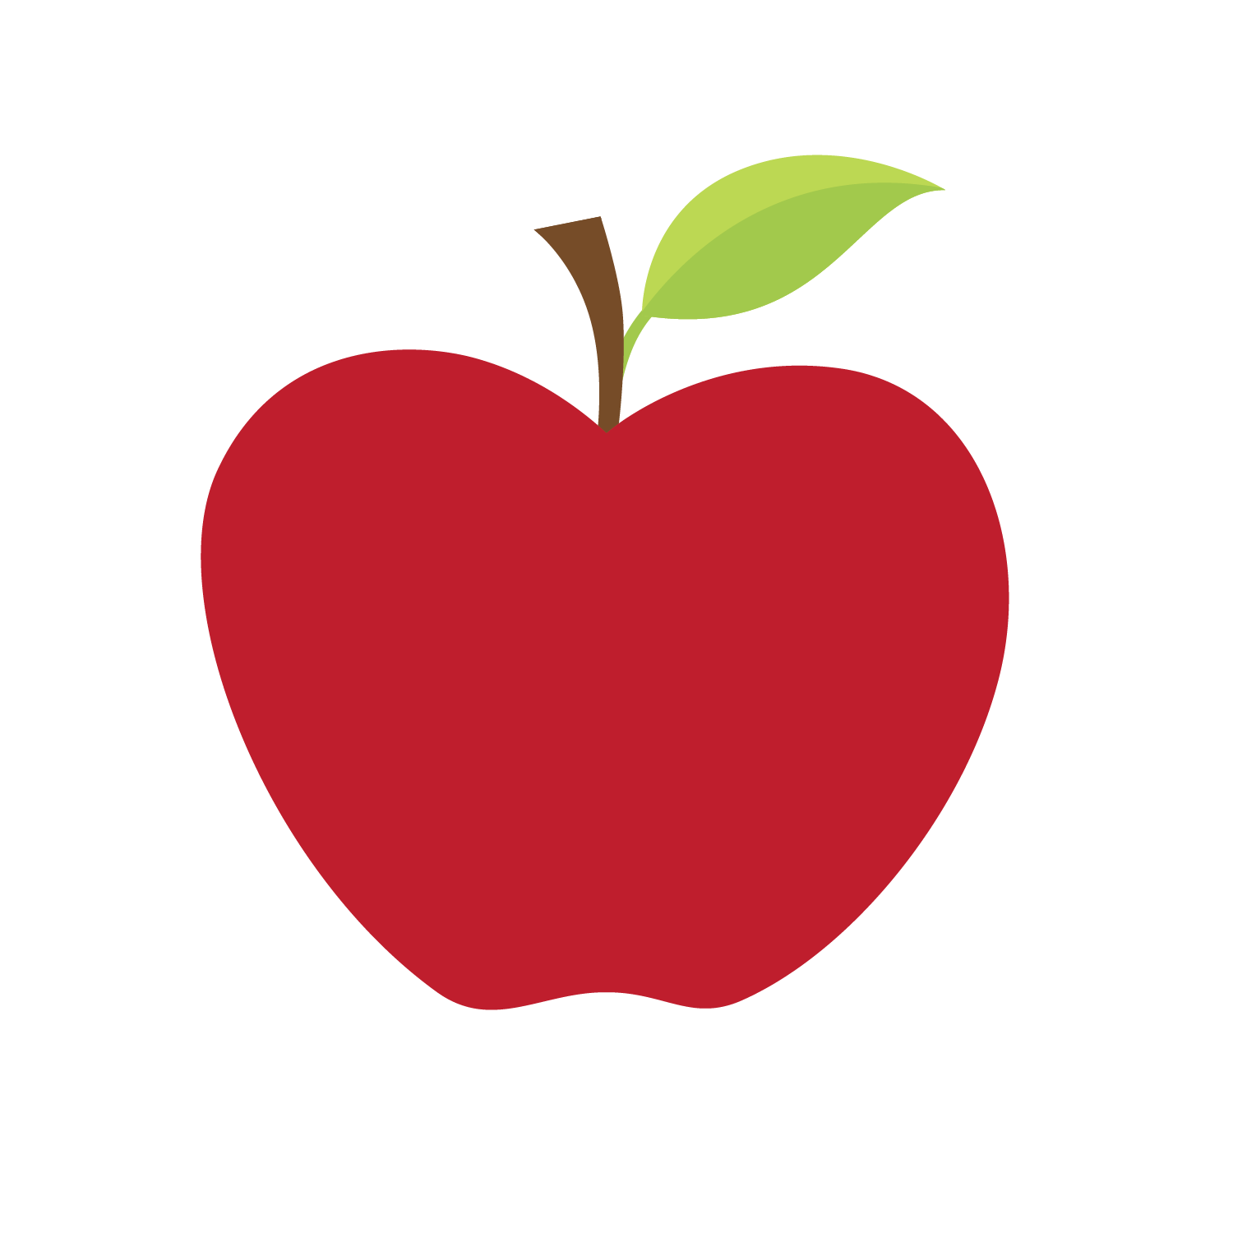
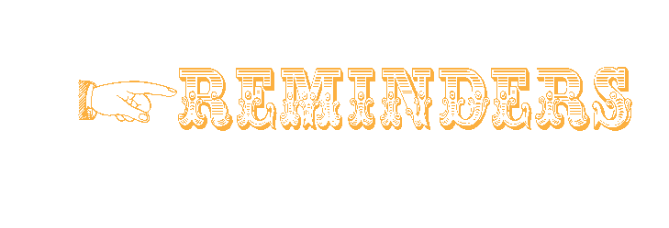
Vocabulary Words
September 22nd - 26th, 2014 • ISSUE 7
We will be attending our
first FIELD TRIP on October 22nd.
We will be going to
Oak Mountain State Park-
more info to come!
Mark this date on your calendar

Our first Open House Night
will be October 7th
from 5:30-7:30

Please sign and return
Parent Conference Note (even if you do not wish to have a conference at this time!)

September 23: Hat Day $1
September 30: Picture Day
October 13 & 14: Fall Break

Our class website…..
Sparks3.weebly.com

encounter- an unexpected/unplanned meeting with
someone or something
conflict- an argument, a fight, or a disagreement

.

Notes from the Teacher
Mrs. Candy Carden • candy.carden@sccboe.org

Look at what we’re learning in Mrs. Carden's classroom!

