READING | WRITING | MATH | SCIENCE | SOCIAL STUDIES
- Nonfiction- locating information & using text features  - ABC order  - Story of week  “Weekly Reader” | - Narrative writing  - Descriptive paragraphs  - Types of sentences | - Place Value  - Expanded, standard, and word forms  - Greater than/less then/equal | - Moon phases  *Please complete observation paper each night | - Globes and Maps  - We will be using “Weekly Reader- Maps” as our reading text for the week!

• September 1: Labor Day (no school)

Notes from the Teacher
Please check and sign your child’s Buzz binder each night…. Please sign and return any papers that are needed to be returned
THANK YOU!!!

Mrs. Candy Carden • candy.sparks@sccboe.org

We are officially in the swing of things, parents!
Spelling Words
Test -- Friday August 22nd
this, saved, taking, shopped,
riding, running, last, clock

Vocabulary Words
Test -- Thursday August 21st
diverse, symbol,
prepare, experiences
Students must know how to spell correctly
^{& use within their writing.}

Look at what we’re learning in Mrs. Carden's classroom!
Sparks3.weebly.com
LADIES & GENTLEMEN!
Please don’t forget our class website

about our class blog!

AUGUST 18th- 22nd, 2014 • ISSUE 2
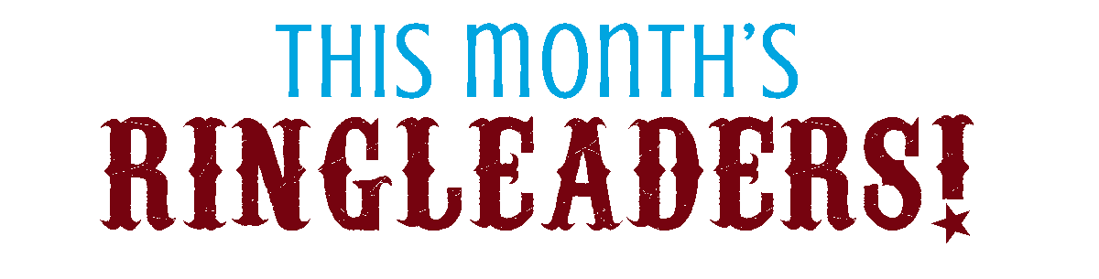
Here are a few pics of our busy week! This week, we got to know one another, learned and practiced our routines, and even had time for a little FUN!
Check us out!
USE THIS SPACE FOR AS MANY PHOTOS AS YOU WOULD LIKE
OR REARRAGE THE PAGE TO FIT YOUR NEEDS.
Feel free to omit this second page.
I use 2 pages in my newsletter occasionally and I put photos and “Ringleaders” for the month in the newsletter at least once.
Each month, I will feature the Ringleaders of the Month! Ringleaders are students that go above and beyond what is expected of them and deserve recognition. A Ringleader will be chosen every week and will get a special treat, special attention, and a big “THANK YOU!” for being a great leader.
PHOTO GOES
HERE
PHOTO GOES
HERE
PHOTO GOES
HERE
PHOTO GOES
HERE

