READING | WRITING | MATH | SCIENCE | SOCIAL STUDIES
- Characters and setting  - ABC order  - Story of week  “Ruby the Copycat” | - Narrative writing  - Sentence structure | - Place Value | - Moon phases  *Please complete observation paper each night | - Globes and Maps
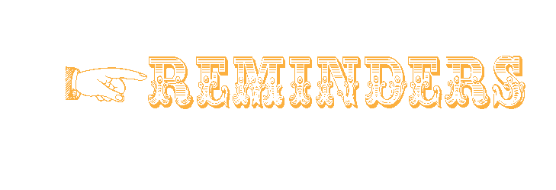
AUGUST 11th- 15th, 2014 • ISSUE 1

• September 1: Labor Day (no school)

Notes from the Teacher
Please check and sign your child’s Buzz binder each night…. Please sign and return any papers that are needed to be returned
THANK YOU!!!

Mrs. Candy Carden • candy.sparks@sccboe.org

We are officially in the swing of things, parents!
Look at what we’re learning in Mrs. Carden's classroom!
We will test on these words
Friday August 15th
again, always, because, believe,
happening, hopped, they, went

Vocabulary Words
We will test on these words
Thursday August 21st
prepare, experiences
Students must know how to spell correctly
^{& use within their writing.}

Spelling Words
Sparks3.weebly.com
LADIES & GENTLEMEN!
Please don’t forget our class website

about our class blog!

